Mr. Santiago/Spanish Teacher

“Every kid is one caring adult away from a success story” ~ Anonymous

I have been in education for four years now, this being my fourth year as a High School Spanish teacher. I always believed that being an educator in a High School would simply entail teaching to ensure students understand the content in order to make sure they achieve a passing grade in the class. Little did I know in this profession, there is so much more than just teaching in a classroom. In my short four years of experience, I have learned that while teaching and learning occurs inside the classroom, it extends beyond the classroom as well. Teaching and learning occurs in many forms extending beyond the classroom, whether it is talking to a student in the hallway about proper school behavior, or when assisting students at study tables with work from a specific class. But as American author who focuses on leadership John Maxwell (2008) once stated, “Students don’t care how much you know, until you know how much they care.”
The quote above is extremely powerful, and especially so when it comes to education. I am a firm believer in developing and obtaining professional teacher-student relationships with my students. Establishing that professional teacher-student relationship helps the student witness how much I truly do care about them, not only as students but as adolescents. Every day, I engage in conversations in the hallways with students. If I ever see a student sad or look like they are having a bad day, I always ask if there is anything I can do to help. The sole purpose is to get them enthused about the Spanish language all the while earning their trust at the same time.
When this “Home Visit” assignment was presented to me in my “Community Relations” class for graduate school, a lot of things went running through my mind. Like I previously stated, I am a firm believer of developing professional teacher-student relationships within my classroom. Making positive phone calls and sending encouraging emails to guardians are some of the few things that I do on a daily basis to develop that professional family relations. Never did the thought of going on “home visits” to students’ houses cross my mind. When reading about “home visits” and witnessing the potential positive impact they can have, I kept thinking to myself if anybody in my school has ever gone on visits to the houses of students. I engaged in conversations regarding home visits with several of my principals. After a few minutes of conversation with the principals, one principal went on to say, “Teacher’s do not go on home visits unless it is an absolute emergency. Privacy is honored at all times and there is no reason to infiltrate the home life anymore for information.” This principal was extremely adamant about “home visits” and respecting the privacy of the life at home of the students and their families.
I left the meeting in shock and was unsure if I was going to be allowed to go on these visits. Several days later, I got permission to go on visits to the house of a few students, only if it was permissible with the parent of the student. I kept thinking if my district is a district of excellence, why would anybody want to go on visits to the house of their students? Is there really a need or purpose for home visits?
Then I remembered when I was younger, when I was in second or third grade. I had just moved to the United States from Puerto Rico a few years prior and was struggling to adapt to traditions in America. In addition, I was struggling with the English language and had difficulty learning how to communicate with my peers. I had a really wonderful and caring teacher that year and she took the time out of her day to visit my house and have a conversation with my parents. That meant a lot to my parents to see that there was somebody out there that really cared about me, somebody that really wanted me to succeed.
In my four years of teaching experience, I had never been on any “home visits” prior. I felt nervous about going on these visits because I wasn’t sure if the encounters with the families would be positive or negative ones. In order to get three different perspectives, I chose to visit three different families from three different types of social classes, working class, lower class, and one upper class family. I knew these families were in these social classes by reading the student profile and recognizing the areas in where they lived. I didn’t know how the families that I selected would respond to me entering their homes and engaging in conversations. Despite my nervousness, nonetheless, I felt excited and eager to take on this new experience. I was looking forward to learn more about my student and their families and make that deeper connection. I was looking forward to establishing a better parent-teacher professional relationship, one that featured face-to-face communication instead of phone calls and emails. Overall, while feeling uneasy, I was looking forward to the experience of “home visits.”

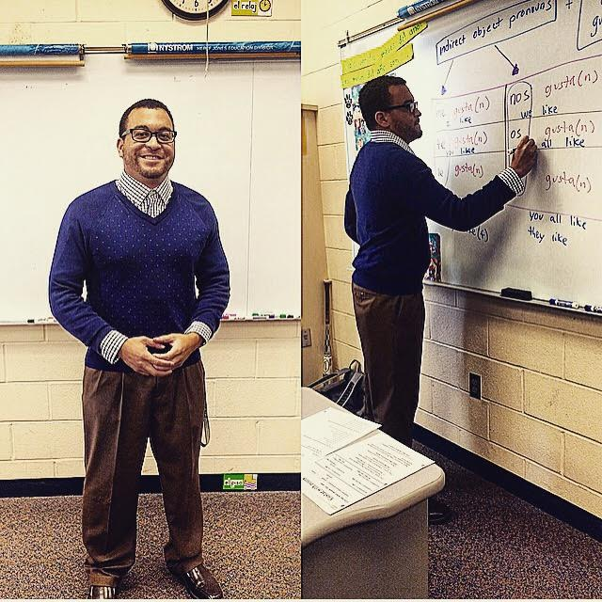
Mr. Santiago/Spanish Teacher

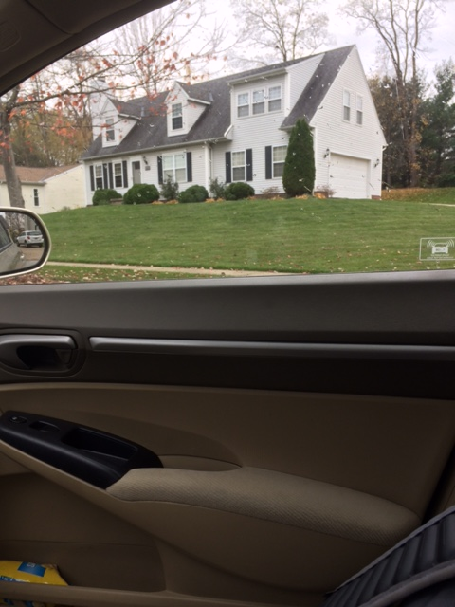
House of student #1 Purdue Owl Figure 1

To keep the families identities confidential, pseudonyms have been used instead of their real names

The first family I decided to visit was the family of one of my Spanish two students, Jane (see note on the left). Jane is a well-rounded individual, organized, responsible with a good head on her shoulders. She never gets into any sort of trouble and always follows the rules. She is an African-American student who is a member of the art club and participates in the girls’ soccer team. I truly appreciate having Jane in my class because she participates frequently, asks questions, assists other students, and completes all tasks in a timely manner. If Jane has any further questions regarding the content in class, she doesn’t hesitate to stay after school and ask questions or ask for additional help. I communicate often with her mother and oftentimes, send positive phone calls home to show my appreciation for all the hard work and effort Jane puts in to my class.
Based on phone conversations with her mother and reading Jane’s profile, I selected Jane because her family is a working class family and wanted to get their unique perspective. When I told Jane about the purpose of this project, she did not hesitate in saying she would feel uncomfortable with me visiting her household, instead, she welcomed the idea of a home visit. I contacted Jane’s mother and asked if it would be acceptable for me to visit their home and ask her questions in order to deepen understanding regarding her child and enhance the professional parent-teacher relationship and build bridges between home and school. I received the same response that Jane mentioned to me, and her mother welcomed the idea of a home visit as well. We set up a time and a date to do the home visit and the rest was history.
The day of the home visit arrived and the time Jane’s family and I agreed on was 3:30pm. I was feeling a little tense because like previously mentioned, I did not know what to encounter. I approached the development of Jane’s family and noticed numerous pretty houses. The area was appealing and the neighborhood seemed to be a colorful and welcoming neighborhood. I had my laptop charged and ready to go. I arrived to the house of Jane’s family and rang the doorbell. They welcomed me with a smile and I entered their house. They guided me through the living room into the family room. Jane’s mother and Jane and I sat down and several minutes later the questioning began.

Below is a summary of the interview between Jane, her mother, and I:

Questions asked to the student
- How are things going?
“Things are going great. The start of this school year has been going really well. The transition from sophomore year to junior year has been pretty good. Soccer season just ended, we came up short in the playoffs this year but already looking forward to next year.”

- How are you doing in school? What do you like about school?
“School is going good. I really like all my classes. Spanish is a little harder than last year but it is coming along. I like art class the most. I like the art teacher. He is really cool and I really like being in his class. Art club this year has been pretty fun too.”

- How are you going to support yourself after graduation? What skills do you have that will aid you in obtaining and keeping a job? What kinds of things are you learning in school that will help you obtain and keep a job?
“I hope to get into something with art, whether it is designing or something where I can use my creativity in drawing and art. I am planning on taking AP art next year. I am also in art club and I spend a lot of time drawing and doing different neat things in the club. Being in school, I have learned how to be organized and responsible. Showing respect to teachers and adults is something my parents taught me and something I believe is important and will help me succeed in life. If I continue to do those things, I feel like jobs will hire me in the future because I feel like jobs will want those qualities.”
- Now I need to ask you a few questions about you and your family. What are some things you enjoy doing? What are some things your family does for fun together? Do you get along with your mother? Father? Sisters? Brothers? Have there been any big changes between you and your mom or dad in the last year?
“I really like when we all get together for the holidays. We are all close and like to spend time together, whether it is playing soccer outside or playing basketball. We also go to church every Sunday and I like spending that time with them. I do get along with my mother and my father, for the most part. There are times when we do disagree on things but I always show respect no matter what. The cool thing about this year is that my little brother is a freshman and I can see him a lot at school. He hates that but I think it’s pretty cool. He can be difficult at times but I believe we are pretty cool.”
- Tell me about your friends in your neighborhood or at school? What are some kinds of things you like to do together? Is there anything you’d like to do, like having a hobby or being in a club that you haven’t been able to do for some reason? Why? Why not?
“My friends are pretty cool. I have a lot of friends on the girls’ soccer team. Some of them can be very dramatic but I get along well with all of them. I have a few friends that live in my neighborhood that I am pretty close with. We go outside and kick the soccer ball around and go for walks. One of my friends just got her license so we go to the mall and go shopping now on the weekends. Some of the guys at school can be very obnoxious which is why I stay away from them for now. My neighborhood friends don’t like to draw so they don’t go to art club with me but that’s ok because I can make new friends at the club.”
Questions asked to the guardian
- What do you do to support the child in being involved in things he likes to do? Do you need any help to do this?
“My child is very artistic. She loves to draw all the time. She is extremely engaged in her art class and loves working in that class. She loves being a member in the art club. I support her by buying her the necessary supplies for her to draw and paint and do all of her art things. She also loves to play soccer. She has been playing soccer since she was little and she continues to play at the high school. She enjoys playing with her friends so therefore I let her play outside when her friends come over. We sometimes even go to the fields to practice. I buy her cleats and soccer balls. I support my child with her academics daily as well.”
- How do you think your child is doing in school? Have you gone to a school conference or received any reports from school? If the child were to have troubles at school, who would you contact? What are your concerns right now?
“My child is doing really well. Parents have the ability to monitor grades using Progress Book so I check on that daily to keep up with her grades. We expect good grades from her because we believe education is extremely important. We want her to go to college and get a good education and do something she loves, which will probably involve art or something with that.” We have gone to school conferences before. We went last year and it was nice getting to know the teachers and their teaching styles. We got to know the principals. I believe if my child were having troubles in school, the best thing to do would be to contact the teacher and ask what’s going on. But, we have no concerns regarding her academics. She has been performing well balancing her education with her extracurricular activities and friends.
- What was/is it like for you to care for this child? To whom do you go if things aren’t going too well?
“We like caring for our child. We have two kids and both of them have been very great. We have been blessed. If things don’t go well, my husband and I have open lines of communication with them and we talk things out. In regards to health, if my child is sick, our healthcare providers are fantastic.”
- What do you need from the school to continue supporting your child?
“The school is such a great place and a great environment for learning. When I walk the hallways during conferences, I see a lot of neat things on walls etc. There are so many caring teachers at my child’s school. It is a district designated Excellent for several years now. I do not need anything from the school as the school provides all the necessary tools for my child.”
- What are your child’s main interests /activities at the moment?
“My child really enjoys art. She is planning on taking AP art next year. She also loves playing soccer. Most days after school, she dedicates time to her homework followed by working on soccer drills outside. Sometimes, her friends down the street come over and practice with her so she can hone her soccer skills. Then at night she spends time drawing. She really loves to draw. I have to keep buying her notebooks after notebooks because she draws so much here at home.”
- What opportunities does your child have for outside play? What do they like to do outside?
“My child loves to play outside with her friends. She will play soccer almost every day that it is nice out. There are times where she plays soccer with her neighborhood friends and they play (4 versus 4) in the street because the neighborhood is relatively quiet and not many cars drive by. On the weekends, our family likes to go to the park and let our kids roam around playing basketball and soccer while my husband and I go for a walk.”
- What experience does your child have of being cared for away from the family?
“When we think about our child being cared for away from the family, we tend to think about our child being in school while my husband and I are at work. The teachers, counselors, coaches and all personnel in school care for our child. When my child was younger, my mother would care for them when my husband and I were at work. That was extremely nice of them to support us with that.”
- What experience has your child had of playing with other children? How is your child in these situations?
“Like previously stated, my child has many friends in our neighborhood and they spend lots of time playing soccer and going for walks. My child is always open to making new friends.”
- How does your child usually react to new situations and with new people?

“We have taught our daughter to not see color as a reason to not talk or hangout with somebody, to treat everybody with respect. I really believe she applies that in life because she gets along well with everybody and makes friends with everybody. From what she tells us, she works with everybody in her classes when they get to work in groups, and she talks to everybody in school. I believe there are a few girls on her soccer team that can be difficult but she always is respectful to them.”
- Do you have any concerns about your child’s development?
“There are no concerns about my child’s development as she is completely healthy. She always has her physicals on file due to soccer and she goes on 6 month checkups to our family doctor.”
- Is there anything else you would like to ask or tell us?
“Thank you for taking the time to come out to our house. Nobody has ever done that before. We hope you get a good grade on this assignment. Please continue to let us know how our daughter is doing in Spanish. We appreciate the constant communication and we hope it continues.”

The home visit went really well. Transitions were fluid and conversation was flowing. Jane’s father was still currently at work so the home visit included only Jane, her mother and I. I thanked them both for their time and for allowing me to enter their home to engage in conversations with them. Jane’s mother appeared to be fascinated with the fact that her daughter’s teacher was there and gave great responses to the questions that I asked. She sat upright utilizing a firm tone of voice yet very friendly, and she made great eye contact. I was really surprised that they gave me the time of day to let me come into their household and engage in meaningful conversations. I was also really astounded at how smooth and positive the dialogue actually went. While I have had communication with Jane’s mother via emails and phone calls prior, I expected weird looks from her as to why I was actually there. Instead, I experienced nothing but positive vibes and significant responses to the questions I was asking. Jane seemed intrigued as to the purpose of the project. I learned from Jane and her family that they appreciate what the school district offers and they value education. They are firmly rooted in their core values of family along being active not only in school but also in the community. They appreciate their time together as a family unit. There were no “challenges” identified. The Jane family is a hard-working family and they pride themselves on being positive and treating everybody they encounter with respect. That to me is admirable and it made me realize the reason Jane is such a hard-working and motivated student in class is because it was instilled in her by her parents at a young age. The following day in school, Jane thanked me for coming to her house and appreciated the time spent with her family. She mentioned that I would be a teacher she would remember forever due to that experience.
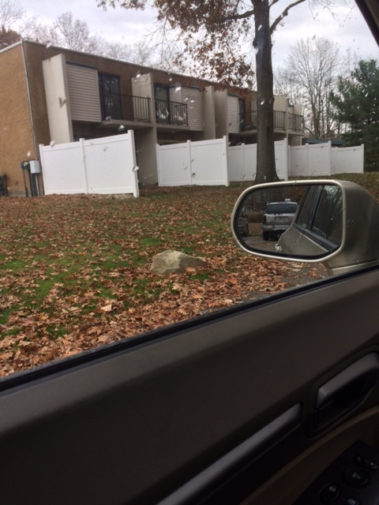
Apartment complex of student #2

The second family I decided to visit was the family of a Spanish one student, John (see note on the right). John is more of a struggling student, who oftentimes forgets to complete assignments, misplaces his materials, and frequently arrives to class late. John is also an African-American student who isn’t very active and doesn’t do much but participates in the black history club. John can be a difficult student to work with as it seems like he simply doesn’t care about school or Spanish class whatsoever. If John decides to check out of class, he won’t do any work whatsoever. Despite numerous efforts to include him in class work and class discussions, he simply won’t put in the effort.

To keep the families identities confidential, pseudonyms have been used instead of their real names
I have had numerous conversations with the school counselor. Additionally, I have had several exchanges with the school social worker regarding John. I found out that John was dealing with a lot at home. In short, John’s mother is a single parent and works a lot to support John and his two brothers. This explained why it is exceptionally difficult to get ahold of John’s mother as I had been able to communicate via email a select number of times. What I also learned in the conversation with the school social worker was John’s mother had been seeing another gentleman and regularly stays at their household.
Similar to Jane, I looked at the profile of John and his family and realized they were a lower class family. My goal was to hopefully get their outlook of school community relations. I had previously tried to contact John’s mother via phone but she was unable to be reached. Once I got to learn more about him and his family, my relationship with John has increasingly gotten better over the months. John will say hello to me more frequently and he will also smile regularly. I have attempted to have more one-on-one communication with John and try to uplift him with positive messages and reinforcement. I knew that asking him for a chance to visit his house and engaging in conversation with him and his family would provide a great perspective. One after class was over, I asked him to stay for a couple of minutes to ask him about going on a “home visit” to his house. I explained to John the purpose of the assignment and asked if I could call his mother to ask her as well. At first, he seemed hesitant, which I expected, but my hope was to have him see how much I cared about him as a student and as a person by getting to know him on a deeper level. A day later, he returned to class and gave me permission to be able to go on a “home visit” to his house. I contacted John’s mother and asked if it would be acceptable for me to visit their home and ask her questions in order to deepen understanding regarding her child and enhance the professional parent-teacher relationship and build bridges between home and school. She agreed to participate and we set up a time and a date for the home visit. I was ecstatic yet more anxious than I was when I visited Jane and her family. The difference was the social class as I knew I would be going into a lower class household. I knew that the situation at home wasn’t ideal and that there was potential for things to escalade if the conversation did not go smoothly.
The day of the home visit arrived and the time Jane’s mother and I agreed on was 3pm, forty-five minutes after school had concluded. It was her only off day from her job and she was able to fit me in. I was feeling extremely nervous because like previously mentioned, I did not know what I would expect. I approached the apartment complex that John and his mother lived and immediately noticed the basketball court with many African-American adolescents playing basketball. Many had piercings and dreadlocks along with baggy pants. The area was a little intimidating because it felt like everybody knew everybody and I didn’t live there so I was intruding their living space. A few of the adolescents stared me down and I even caught a glimpse of a few other students that attend the high school. My mind was racing with the questions that I would be asking John and his mother. Similar to Jane, I had my laptop charged and ready to go. I arrived to the development of where John resides and I knocked on the door. I noticed the doorbell was faulty and not functioning. John welcomed me in and immediately I saw his two younger brothers playing in the apartment complex while John’s mother was on the phone getting ready to prepare dinner. The apartment complex was not welcoming at all and I followed John into the little dining room area right next to the kitchen. I politely introduced myself to John’s mother as she finished her phone conversation. John’s mother, John and I sat down and some minutes later the questioning began.

Below is a summary of the interview between John, his mother, and I:

Questions asked to the student
- How are things going?
“Things are going ok. As you can already tell Mr. Santiago I am not doing so well in school. I do not like school. A lot of my friends and I think school is a joke; it’s just all busy work and no point. Sometimes I wish I didn’t have to go to school. You’re pretty tight but I don’t like any of my other teachers. They understand me. It seems like they are just teaching just to teach. I cannot respect that. The only thing I like about school is being in the Black History Club. They are pretty cool. Other than that, things are just whatever.”

- How are you going to support yourself after graduation? What skills do you have that will aid you in obtaining and keeping a job? What kinds of things are you learning in school that will help you obtain and keep a job?
“I haven’t even thought about that. The only thing I can probably think of is getting a job in anything to help support my little brothers. I’m still too young for a job but I hope within the next year, I can get a job somewhere where the pay is good. Skills, honestly, not many people know this about me but I would like to think that I am good at math and science. I do well on my quizzes and tests; I just don’t care enough about homework and all the extra stuff. Maybe someday I can get a job where I can use my math and science skills.”
- Now I need to ask you a few questions about you and your family. What are some things you enjoy doing? What are some things your family does for fun together? Do you get along with your mother? Father? Sisters? Brothers? Have there been any big changes between you and your mom or dad in the last year?
“I really like spending time with my little brothers. We play outside all of the time. Now that the leaves are out, we gather leaves together and I throw my little brothers in the leaves. We don’t have much money to do much. Every once in a while we go out to eat but that is on a rare occasion. That is why I want to work so I can help my little brothers out and get things for them from time to time. I love my little brothers and will do anything for them. My mother and I, our relationship has been a little rocky lately. I love my mom and I don’t have a relationship with my dad since he left when we were all younger. But sometimes mom doesn’t understand me. I feel like nobody understands me.
- Tell me about your friends in your neighborhood or at school? What are some kinds of things you like to do together? Is there anything you’d like to do, like having a hobby or being in a club that you haven’t been able to do for some reason? Why? Why not?
“My friends are pretty tight. I have a few close friends who are like brothers to me. We kick it at the neighborhood park and play basketball. A few of my neighborhood friends also come to the Black History Club with me. I am not interested in anything else.”
Questions asked to the guardian
- What do you do to support the child in being involved in things he likes to do? Do you need any help to do this?
“I try and help my child by providing food on the table and making sure he has clothes to wear. I work so much and pick up extra hours at my job to help provide for them and sometimes it’s hard to make ends meet. I do need help and my partner that I am seeing helps me out sometimes.”
- How do you think your child is doing in school? Have you gone to a school conference or received any reports from school? If the child were to have troubles at school, who would you contact? What are your concerns right now?
“I think my child is doing ok. I have not gone to any school conferences because I have no time to go. I am always working. I know my child struggles sometimes with his school work but that is why I trust the teachers at his school to help him achieve his goals. Some of his teachers call but I can’t answer the phone at work. Sometimes my computer doesn’t work right so when I get a chance, I check my email using the computer at my job. John complains sometimes about school and not wanting to go and that scares me at times. I don’t want him to drop out because I know his little brothers’ look up to him and his little brothers need him.”
- What was/is it like for you to care for this child? To whom do you go if things aren’t going too well?
“It can be hard sometimes because being a single parent; I have no support but my partner. John’s dad left us when all the boys were little. We haven’t heard anything from him since he left. I work so hard but it is so hard to do it by myself. I have no support from my family because of all the mistakes I made when I was younger. I can’t look back and feel sorry for myself now because I have three boys to take care of. I have to do the best that I can with what I have. It is hard for John to understand that. He believes that I don’t care about him. This is not true.”
- What do you need from the school to continue supporting your child?
“I know the school district is a really school district and I just need to the teachers to work with John and help him as much as they can. I understand that John can be difficult but I know there is potential. I’m hoping teachers can pull that out of him.”
- What are your child’s main interests /activities at the moment? What opportunities does your child have for outside play? What do they like to do outside?

“My child enjoys playing with his brothers and being with his friends. He can be very quiet at times until he gets to know you. Only then is when he will open up to you. John loves to play basketball outside with the neighborhood kids. There is a basketball court in our complex as you saw outside and a lot of the kids go there to play basketball and hangout. Also, I know John loves to attend Black History Club at school. It seems like that is one of the few places he can be himself.”
- What experience does your child have of being cared for away from the family?
“When my kids were younger, it was really hard for me as a single mother to provide and take care of them. There were times where I asked my next door neighbors to watch the kids when I was at work. One time, I brought John to work before he was old enough for school. John’s father was never in the picture, day care was too expensive and I couldn’t afford it, and I had no support from my family.”
- What experience has your child had of playing with other children? How is your child in these situations? How does your child usually react to new situations and with new people?
“John has many friends in the neighborhood. He plays with everybody to my knowledge. I know they like to go to the courts and play basketball. Everybody calls him Big John because he is a little bigger than the other kids. But despite being a little bigger, I know my John is a big teddy bear at heart. He just takes a lot longer to open up to new people.”
- Do you have any concerns about your child’s development?
“No concerns about my child’s development. Seems like things are going well I believe. I just wish he would open up a bit more and talk, pay attention in class, and be more responsible about his school work. I want him to grow up, unlike me, and get a good job where he can use his many talents. I want him to go to college and get a degree. I can only hope he is on track to do that.”
- Is there anything else you would like to ask or tell us?
“Thank you for coming out. I know my place isn’t the nicest but thank you and I hope everything goes well with school. Please continue to work with John. I know he can be difficult but I want him to do well. I will try my best to have more time to work with him and communicate with his teachers.”

Despite my nervousness and anxiousness, I thought the home visit went exceedingly well. In the beginning, the neighborhood was a bit intimidating with everybody looking at me. Prior to the home visit commencing, John’s mother was also a bit intimidating because she was on the phone and it seemed like she had no time for me. Essentially, I was preparing myself for the unexpected. But once I introduced myself and explained the purpose for my visit, she sat down and answered every question. Throughout the questioning, it almost seemed like she was opening up and letting go of all the pain inside of her. So much information was revealed and immediately I understood why John was so quiet. I learned that the mother had been trying hard to provide for John and his brothers. It seemed like she was overworked because she was running out of breath when talking to me. I was surprised at how honest John’s mother was and the struggle she has been through to be able to help support her family. I was under the assumption that she just didn’t care for John because of her new partner. The reality was the partner had been helping her provide for her kids as it seemed like she wasn’t capable of doing so alone.
I got to meet John’s little brothers and they were pretty cool. They were full of energy and I saw the deep connection John had with them. Despite the apartment not being tidy and welcoming, the boys brought energy and life to the family. I told them that I would see them in a few years once they got to high school to take Spanish. It was noticeable that John’s family’s funds of knowledge are “Friends and Family.” In spite of John’s mother not being to properly portray her love for her boys, she deeply cared for them. Moreover, John being a good big brother showing compassion and love is a sign that he genuinely cares for his brothers.
John faces numerous challenges. Throughout the home visit, I was able to visibly see the disconnect in the relationship between John and his mother. While John’s mother sincerely cares and worries for John and his brothers, the way she displays that affection is not clear. John struggles with not having a father figure and role model in his life. Therefore, he doesn’t have a male figure to hold him accountable for any negative actions he may display. In school, it seems like teachers don’t reach out to him and see him as just another number in the class. John mentioned that people don’t understand him. I now comprehend the difficult position life has put him.
The following day in school, John approached my class without saying a word. After class, he came up to me and shook my hand for taking the time of my day to come to his house and engaging in a conversation with his family. He mentioned the experience opened up his eyes a little bit and he was able to comprehend the challenging position his mother is in. John and his mother engaged in conversation shortly after I left and their journey to better understanding one another had begun. He left class on a positive note stating he would try harder and be a better student.

House of student #3

To keep the families identities confidential, pseudonyms have been used instead of their real names
The third family I decided to visit was the family of another one of my Spanish two students, Jodie (see note on the left). Jodie is an intellectual young lady, who prides herself on being organized, responsible, and respectful. Jodie is a senior who is Caucasian and is on the school basketball and softball teams. Similar to Jane, I really appreciate having Jodie in my class because she participates regularly, asks questions, helps other students, and finishes all tasks in a timely manner. Jodie will stay after class and sometimes after school, will be excused from basketball to receive extra help.
I talk with Jodie’s mother every so often because I had Jodie last year in my Spanish 1 level. I met Jodie’s mother at parent-teacher conferences last year and could tell she was a very nice mother who prioritizes education within her family. Based on prior conversations with her mother and reading Jodie’s educational profile, I selected Jodie because her family is an upper class family and wanted to get their unique perspective on school-community relations. When I told Jodie about the purpose of this project, she said it would be pretty neat to have her Spanish teacher come to her house to speak with her family.
I contacted her mother via phone call and told her the reason for the phone call, and the purpose of the assignment. I asked if I could visit their home and engage in conversation in order to deepen understanding regarding her child and enhance the professional parent-teacher relationship and build bridges between home and school. I had a feeling that Jodie’s mother would say “yes” because I understood from prior communication with her that she appreciates education. We agreed on a time and date and concluded the phone conversation.
The day of the home visit arrived and the time Jodie’s family and I agreed on was 4:30pm. Due to the fact that I had already been on two prior home visits, I was not feeling quite as nervous and uneasy. The area was extremely engaging and the neighborhood seemed to be a wonderful neighborhood, a great place to raise a family. The houses were colorful and the neighborhood was very welcoming. I arrived to the house of Jodie’s family and rang the doorbell. They welcomed me with a smile and I entered their house. Jodie’s mother and Jodie were the only ones present at the house. Jodie’s father was out of town on business and Jodie’s brothers were not home either. They showed me around their house and offered me something to drink and cookies. I politely accepted and thanked them for letting me visit their house. We talked for what seemed to be an eternity but I was able to cue them in to starting the conversation. Jodie’s mother, Jodie and I sat down and the conversation began.

Below is a summary of the interview between Jodie, her mother, and I:

Questions asked to the student

1) How are things going?
“School and basketball practice are both keeping me busy. I’m excited for our first upcoming game!”

2) How are you doing in school? What do you like about school?
“I have all A’s and one B in school this semester. I really enjoy my math class. It has always been my favorite subject! Social Studies is difficult for me. That is the class I have a B in. I have to study harder in that class than every other subject. I think because it is not as interesting to me.”

3) How are you going to support yourself after graduation? What skills do you have that will aid you in obtaining and keeping a job? What kinds of things are you learning in school that will help you obtain and keep a job?
“I plan on working my summer job, which is being a secretary at a family friend’s company, until I start college in August/September. I have worked a variety of different summer jobs and participated in many service projects throughout high school which gives me a variety of different skills to aid me in obtaining and maintaining a job. In school, not only am I learning all the educational items such as math, science, Spanish, and literature, but I am also learning how to be a respectful person and productive member of society.”

4) Now I need to ask you a few questions about you and your family. What are some things you enjoy doing? What are some things your family does for fun together? Do you get along with your mother? Father? Sisters? Brothers? Have there been any big changes between you and your mom or dad in the last year?
“I love playing sports outside in the summer with my brothers. We are all very competitive so it is fun playing basketball, football, baseball, soccer, etc. with them. I like riding my bike and going for hikes as well. Once the weather changes and it gets colder my family will play board games and watch movies together. We eat family dinner together almost every night, as long as my brothers or I don’t have a sports game. I get along with my father better than my mother, I think because she and I are so similar. We bump heads a lot, but always seem to work it out. My dad and I are close, I think because I am the only girl. I get along with all three of my brothers very well, but my middle brother and I fight a lot. There have not been any big changes between my parents recently. My mom and dad still have the same jobs.”

5) Tell me about your friends in your neighborhood or at school? What are some kinds of things you like to do together? Is there anything you’d like to do, like having a hobby or being in a club that you haven’t been able to do for some reason? Why? Why not?
“I have a big group of friends in my neighborhood. We have all grown up together since we were little. We play capture the flag, ghost in the graveyard, sports, and all sorts of things in the summer. In the winter we all go sled riding together at least once and have snowball fights all the time. My friends at school don’t live in my neighborhood, but we see each other all the time at basketball and softball. I wish I was more involved at school in clubs, like student government, but I feel that I am too shy. I am content with school and sports.”

Questions asked to the guardian

6) What do you do to support the child in being involved in things he/she likes to do? Do you need any help to do this?
“I go to almost every single one of my daughter’s basketball and softball games. I love to watch her play! Majority of the time my husband is at the games with me as well with our younger boys. I do not need help supporting my daughter in activities she enjoys.”

7) How is he/she doing in school? Have you gone to a school conference or received any reports from school? If the child were to have troubles at school, who would you contact? What are your concerns right now?
“I always have open lines of communication with my daughter regarding school; however she doesn’t give me any trouble, like my sons. She does a good job turning in homework and studying for tests. Sometimes she needs a little encouragement at home to stay on task. I did not attend conferences this year because my daughter had all A’s and one B. If my daughter was having trouble at school I would first discuss the issue with my daughter. If she and I could not solve the problem, I would directly contact the teacher in which subject she was having difficulties. I don’t have any concerns for my daughter in school at this time.”

8) What was/is it like for you to care for this child? To whom do you go if things aren’t going too well?
“My daughter and I bicker and fight, as I’m sure most mothers do with their teenage daughters. My daughter and I overall have a good relationship and she comes to me with almost everything. If my daughter and I cannot compromise I will discuss with my husband. He is also very involved in my daughter’s life as well as my sons too.”

9) What do you need from the school to continue supporting your child?
“I want to make sure the school continues to challenge my daughter in her school work in order to improve her skills and knowledge set to prepare her for college.”

10) What are your child’s main interests /activities at the moment?
“My daughter loves sports, especially the Cleveland Cavs, and spending time with her brothers and friends. There are always other kids at our house playing outside or in the basement.”

11) What opportunities does your child have for outside play? What do they like to do outside?
“All of my children are always outside playing during the summer and even in the winter when the weather allows. We have a large open backyard where most of the neighborhood kids gather to play sports and/or night time games. We have a basketball hoop and nearly any sporting equipment you can think of. They play basketball, football, soccer, baseball, tennis, kick the can, etc.”

12) What experience does your child have of being cared for away from the family?
“When my husband and I have gone out of town for work trips or vacations without the kids, they have stayed at my parents’ house. This is maybe once per year. My daughter has had sleepovers at her friends’ houses and I have never had another parent tell me she was disrespectful or causing trouble. My daughter and her friends aren’t the trouble making kind. They would rather watch a movie in the basement then go out and cause mischief.”

13) What experience has your child had of playing with other children? How is your child in these situations?
“My daughter plays with her neighborhood friends on a nearly daily basis and her school friends regularly too. She interacts very well with others she knows, but can be shy if she is put in situations with unfamiliar people. She loves to play and is more of a peacemaker than trouble causer. She will even calm her brothers down in competitive situations.”

14) How does your child usually react to new situations and with new people?
“My daughter is shy when placed in new situations or with new people. She isn’t one to start conversation with new people, however if she is approached and conversed by another person, she is polite and personable.”

15) Do you have any concerns about your child’s development?
“My daughter is intelligent and athletic. I think mentally and physically she is developing normally. I do not think my daughter has much of an artistic or musical side, but she keeps busy with school and sports. I hope to see her attend college and excel in whatever she chooses to study.”

16) Is there anything else you would like to ask or tell us?
“How is she doing in Spanish class?”

The family of Jodie was so welcoming and nice. My nervousness from going on a home visit was gone as I had already been to two home visits prior. I felt very comfortable at the home of Jodie. Being at Jodie’s house, I was able to see the sense of unity and family. Jodie has a big family with three brothers and they all get along well. Being the only lady, I was surprised to see how well she gets along with her brothers. Also, I was surprised at how Jodie gets along better with her father than her mother. It was noticeable that Jodie’s family’s funds of knowledge are “Friends and Family, Family Outings, and Family Values and Traditions.” Being a bigger family, they all manage to find time to spend with each other and hangout as a family.
Both parents have really good jobs and live in a really nice neighborhood. Jodie’s mother mentioned how she values education in the family. Jodie’s mother and Jodie’s father both have their Master’s degree, allowing them to have good jobs and live a very nice, comfortable lifestyle. I was surprised that despite a two-parent income household, neither of the parents assisted with the tuition of their older kids. They do not plan on helping Jodie with college as well. They want their kids to be able to learn how to manage college on their own in order to feel self-worthy of their accomplishments in the future. In my eyes, that can be a challenge because college can be very expensive and if any of the Jodie’s siblings, or even Jodie herself messes up in college, they might not be able to afford it.
Jodie and her mother really appreciated me coming into their home and engaging in conversation. Similar to the other families, they wished me well in my college endeavors. The following day in school, Jodie thanked me for coming to her house and appreciated the time spent with her family. She gave me a thank you card which really meant a lot to me.

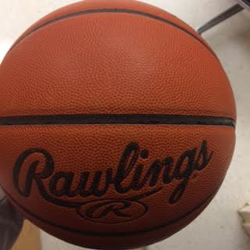
Thank you Card written by Jodie Basketball from John’s house

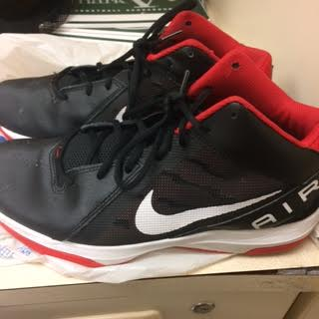 John’s basketball shoes

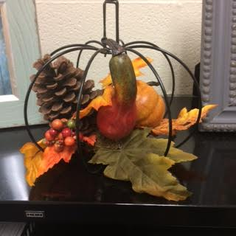 Decorations in Jane’s house

~Reflection~

I learned something from each of my home visits I went on. Despite my nervousness and anxiousness, I had a great time at each of the homes of the families I visited. I gained a lot of valuable knowledge not only about my students and their lives, but about myself as well. There were a few common themes between all three home visits. Jane’s family, John’s family, and Jodie’s family all value “family and friends” as their Funds of Knowledge. In some way shape or form, each family prides themselves in caring for one another, hanging out with one another, and looking out for one another. This is a very essential piece of information to understand.
As I mentioned previously, I have learned that while teaching and learning occurs inside the classroom, it extends beyond the classroom as well in many, countless forms. As educators, it is important to be knowledgeable in our areas of content but it is also important to develop a professional teacher-student relationship as well. You can know the academic standards inside and out, and write the most creative lesson plans, but if positive, affirming, and mutually respectful relationships are not the norm in our classrooms, no learning will take place. Even academic knowledge must be distributed through social relations (Gonzalez, Moll & Amanti, 2005). Professional teacher-student relationships are extremely important for students when they are in high school and as John Maxwell (2008) once stated, “Students don’t care how much you know, until you know how much they care.” Students look up to us educators and we must find the time to engage in conversations and listen to their stories, as we have the potential to learn so much about them, as I did in my experience.
In John’s case, I had no idea that his home life situation was as tough as it was. Meeting with his mother and engaging in conversations with his family led me to understand more about his family background and upbringing. Once I was able to connect with John, I was able to understand him a little better. I understood his love for basketball and hanging at the basketball courts with his friends and little brothers (picture shown above). John did not care about his education because he did not have a male father figure to guide him down the right path. Nevertheless, by having numerous conversations with John, I was able to inspire him a little bit and give him hope. Hope can be sold, it can be taught or at least spread, and it can survive in the strangest and most likely places (Kohl, 1994). I took a picture of his basketball because I felt that basketball was his hope. I learned that John wanted to be on the basketball team but his grades would not permit him to do so. However, talking to him about basketball and seeing his passion for it, he spread that passion to his little brothers and therefore gave his little brothers hope that everything would be ok. John gave his family hope and gave me hope by telling me that he would try harder in all of his classes. It was definitely a fulfilling feeling.
My goal within this experience was to engage in conversations with three different families from three different social classes to gain a unique perspective regarding school community relations. The upper class family (Jodie) and the middle class family (Jane) all valued education within their families. The lower class family (John) was not able to make education their priority due to their situation at home. Affluent communities tend to have a more positive family involvement, on average, while schools in more economically depressed communities make more contacts with families about problems and difficulties their children are having (Epstein et. all, 2009). Additionally, single parents, parents who are employed outside of the home, and parents who live far from the school are less involved (Epstein et. all, 2009). This scenario is especially true when it comes to John and his family. They live in an uninviting apartment complex while Jane and Jodie’s family live in great neighborhoods respectively. The data shows that Jane and Jodie achieve much higher grades that John does, and that is because their families have constant communication with the school.
I learned a great deal from these home visits about myself. I came into this experience not knowing what to expect and came out a new person. Home visits can be a wonderful thing to help schools, communities, and families connect as one. It is extremely important to view students as children and see both the family and the community as partners with the school in the children’s education and development (Epstein et. all, 2009). As educators and administrators, we cannot view children simply as students, because then schools are likely to see the family as separate from the school, leaving the education of their children to the school (Epstein et. all, 2009). We have got to reach out and connect with the students and their families, engaging them in what is going on within our school community. We want to give those families a voice and let them see what is occurring inside our schools. As educators, we must take risks in and outside our classrooms. Risk taking is at the heart of teaching well (Kohl, 1994). While being nervous, anxious, yet excited prior to going on home visits, I am glad I went because I now can use home visits to further connect with my students and their families, aiding in creating a successful family, community, and school partnership.

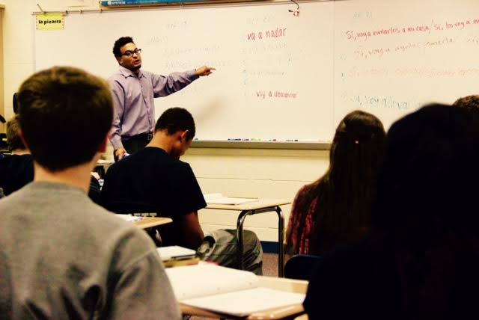 Mr. Santiago/Spanish Teacher

References

Epstein, J. L., Sanders, M. G., Sheldon, B. S., Simon, B. S., Clark Salinas, K., Rodriguez Jansorn, N., Van Voorhis, F. L., Martin, C. S., Thomas, B. G., Greenfeld, M. D., Hutchins, D. J., & Williams, K. J. (2009). School, family, and community partnerships: Your handbook for action (3rd ed.). Thousand Oaks, CA: Corwin Press.

Gonzalez, N., Moll, L. C., & Amanti, C. (2005). Funds of knowledge: Theorizing practices in households, communities, and classrooms. New Jersey: Lawrence Erlbaum Associates.

Kohl, H. (1994). I won’t learn from you. New York, NY: The New Press.

Maxwell, J. C. (2008). Team : the 17 indisputable laws of teamwork : winning with people: John C. Maxwell. Thomas Nelson.

